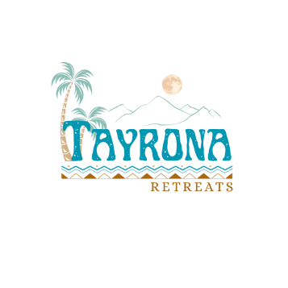

Retreat Participant Questionnaire
For participants joining a retreat with ancestral remedies

Personal Information
Date & Location of the retreat:
Name:
Phone no. (+ country code):
E-mail:
These questions are not entry requirements, but necessary details for us to be aware of and personalize the program according to your needs and preferences.
Health Considerations:
1. Have you experienced any significant illness or undergone surgery in the past? If yes, please share when it occurred and the reason for it.
2. How is your overall health status? Are you under any treatment?
3. Do you have any transplant, implant or pacemaker?
4. Do you suffer from any mental illness?
5. Are you currently receiving any conventional medical or psychiatric treatment, or have you received such treatment in the past?
6. If female, are you pregnant or breastfeeding?
7. Are you allergic or intolerant to any food?
8. Do you currently struggle with any substance use or addiction? If yes, please specify the substance and the frequency of use.
9. Do you have an alcohol addiction?

Retreat Considerations:
1. Is it your first experience with Ayahuasca or other ancestral remedies?
2. If you have previous experience with ancestral remedies, how would you briefly describe your experience?
3. What intentions and expectations do you have from this retreat?
4. Is there anything else you would like to mention, share or ask?

Personal Responsibilities:
I did not consume any drugs within 48 hours prior to the retreat.
I have been properly informed of the activities that are included in the retreat and I have decided with my own free will to participate in the retreat.
I have no professionally diagnosed, physical or psychiatric illness that I have hidden from the organizers.
I will not use cell phones or cameras to take pictures or videos of the retreat, without the consent of everyone present or involved.
NAME AND SURNAME:

SIGNATURE OF THE PARTICIPANT:

